HTML Assignment

1. Create the following html page:



1. Create the following table using html:



1. Write the HTML & CSS code to recreate the following page:



1. Create a simple HTML form as follows:

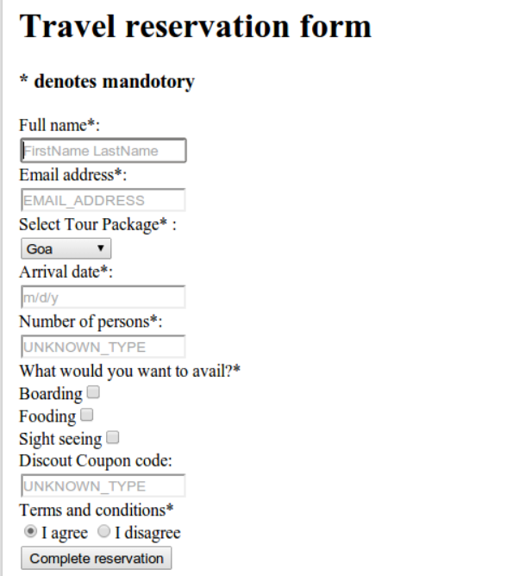

1. Create the following :

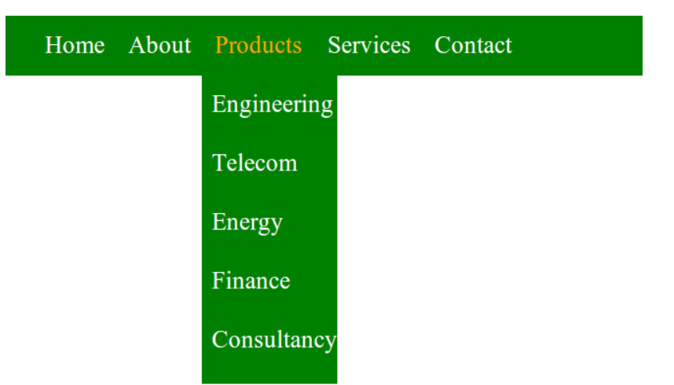

1. Create the following button:



1. Create a simple HTML page having a complex table:

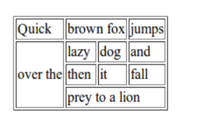

1. Create the following table using css:

